SOCIETY FOR GEOLOGY APPLIED TO MINERAL DEPOSITS
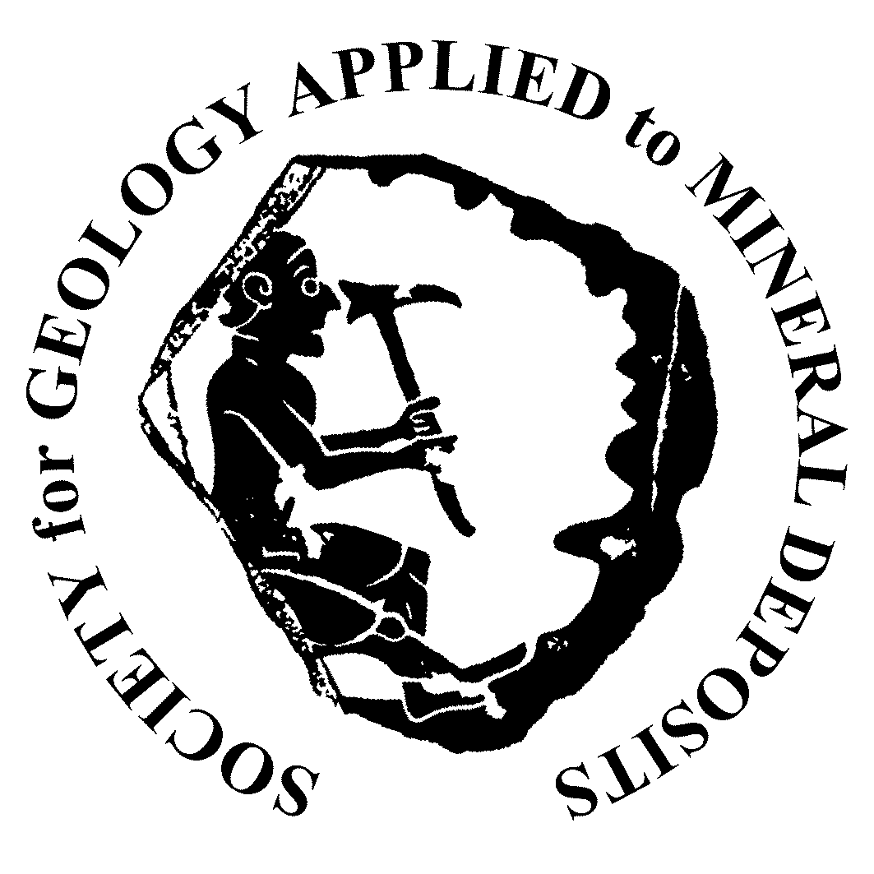

SGA-NEWMONT GOLD MEDAL
NOMINATION FORM

DATE: ____________
NAME OF CANDIDATE: ____________________________________________________

ADDRESS: _________________________________________________________________
______________________________________________________________________________________________________________________________________________________________________________________________________________________________________________________________________________
BIOGRAPHICAL INFORMATION (use format style in American Men and Women of Science, Who´s Who in America, or similar biographical listing: SGA record available from the SGA Office)

SUMMARY OF MAJOR CONTRIBUTIONS OR ACHIEVEMENTS (up to 300 words)

__________________________________________________________________________________________

SOCIETY FOR GEOLOGY APPLIED TO MINERAL DEPOSITS

SGA-NEWMONT GOLD MEDAL NOMINATION FORM

SIGNIFICANT ACCOMPLISHMENTS/PUBLICATIONS: (for accomplishments, give specific examples; for publications, list no more than 5 titles, and attach copies)

Individual nominations for any of these awards MUST BE SUPPORTED by three signed letters from SGA Members. The letters may be attached to this form or sent separately. Supporting letters should emphasize the significance of the nominee’s contributions. All information must be verifiable.

NAME OF PERSON MAKING NOMINATION: ________________________________

ADDRESS:_______________________________________________________________________________________________________________________________________________________________________________________________________________________

DATE:______________ SIGNATURE: _________________________________________

LETTERS OF SUPPORT WILL BE SUBMITTED BY:
1. _________________________________________________________________________
2. _________________________________________________________________________
3. _________________________________________________________________________
RETURN TO:
SGA EXECUTIVE SECRETARY
Dr. Jan Pašava
Society for Geology Applied to Mineral Deposits

Czech Geological Survey
Klárov 131/3
118 21 Praha 1, Czech Republic
Tel. ++420-251085506, Fax ++420-251818748
Email: secretary@e-sga.org; jan.pasava@geology.cz
http://www.e-sga.org

with a copy to Chair Award Committee
Dr. Iain Pitcairn
Department of Geological Sciences
Stockholm University
Svante Arrhenius väg 8, SE-106 91 Stockholm, Sweden
Email: iain.pitcairn@geo.su.se
Tel: +46 (0)8 674 78 38

DEADLINE: March 31, 2019

