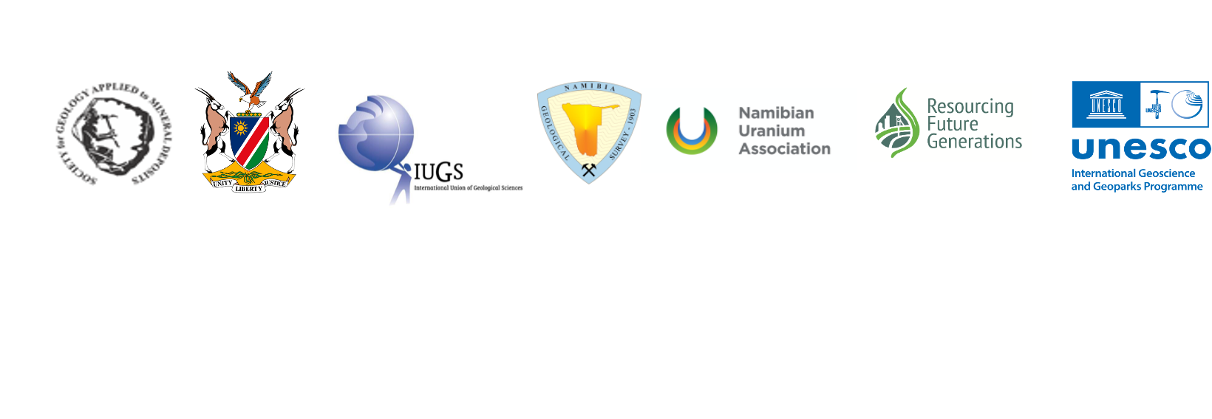

SGA seminar on African metallogeny 2022
Can Africa reach net C-neutrality by 2050?

Introduction
The European Parliament defines carbon neutrality as "the balance between carbon emissions and the absorption of carbon from the atmosphere by carbon sinks".
The challenges are (i) drastic reduction in anthropogenic greenhouse gas (GHG) emissions from using fossil fuels (coal, oil, natural gas), mainly in electricity production, transportation and energy intensive industries, such as cement manufacture and steel making, while finding solutions for (ii) CO₂-CH₄ removal from the atmosphere by using natural carbon sinks such as forests by reforestation, bogs and sustainable land use. The use of innovative technologies can also contribute to CO₂ removal and reduction.
Low carbon strategies are/can be defined at local, regional, national, and continental scales.
Reaching these goals while managing a sustainable transition will require synchronized efforts across key economic sectors, such as energy, industry, construction, transport, land use and lifestyle, and require geoscientists to work closely with social, economic, and political scientists. This seminar is addressed to students (MSc, PhD), young scientists and industrials.

OBJECTIVE
The objective of this seminar is to work in international groups (cross-country) on a topic developed and proposed by the working group (2-3 people). The topic should fit in one of the 3 major topics presented above. Each group is advised by 2 professionals from the organizing committee. For information, some key questions are outlined below.

The tasks are:
- Preparing a common power point presentation (members of the organizing committee will interact and offer guidance)
- Giving a 30 min. presentation of the topic and outcomes by Skype/Zoom/Teams for all including the organizing committee, followed by 20 min. discussion.
- Writing a ½ page abstract in English.
- An article can be written to be published with help of the organizing committee members.

The committee will deliver a SGA certificate after evaluation.

This seminar is organized around 3 major topics. In each topic, discussion points are outlined.

- Environment-Technologies
- What are the environmental strategies and solutions that need to be enforced during exploration for metals considering the green hydrogen energy? Most African countries have issues where during exploration activities the environment is damaged when targeted commodities are not discovered, and no rehabilitation is undertaken
- In addition, with the introduction of green hydrogen energy what are the potential environmental impacts associated with this and what are the solutions to address the identified potential impacts?
- Land clearance will need to take place, leading to potential soil erosion and gullying during heavy rain which can cause green hydrogen infrastructures to be damaged. What are the solutions?

- Social
- What is the social impact in African societies caused by C-neutrality by 2050?
- What effect will this have on employment in Africa?
- How will Industries 5.0 (https://ec.europa.eu/info/research-and-innovation/research-area/industrial-research-and-innovation/industry-50_en)change employments?
- How can this impact be mitigated?
- Will this worsen the employment conditions?
- What can be proposed to fill the gap between social and C-neutrality regarding industry 5.0? The gaps should be filled with possible solutions and statistics to back-up their solutions.

- Governance
- What is the African Mining Vision(AMV)? Is there a good understanding of what it says and how it might be achieved?
The AMV ties permission to mine to the developing added values from mined products. Rather than export ore concentrates, the AMV wishes to see value added in country. To achieve that depends on various factors including the availability of stable electricity supply, transportation (road and rail), a trained workforce, technology transfer, export of mine concentrates between neighboring countries and tariff barriers, (paper by Beretta and Harvey, in press).
- Understanding the African C footprint.
- Is this footprint estimated, calculated, accurately/ conservatively?
- Defining goals to reduce the footprint (defined before), offsetting all remaining emissions
- Reduce emissions on these goals/targets
- Demonstrate and communicate these actions

Some key questions to help developing topics by students, young scientists, and industrials.
- Carbon sequestration There are at least two elements here – biological sequestration by reforestation and restoration of bogs (relatively low energy), and carbon capture and storage which can involve retrofitting coal-fired power stations to extract flue gases, compress them, transport by pipeline to a well head and inject into saline aquifers of redundant oil fields (high energy).
- Green technology (ies)
- Can Africa afford this (economically or technologically)? [Many African countries do not have diversified economies and rely on mining incomes. Do we know what percentage mining incomes account for in a representative group of African countries?]
- How is it possible?
- Storage systems?
- How can Africa position itself to make the required metals/raw materials available?
- How can Africa be in the material value chain? Mining-processing-product manufacturing? At present: raw material exported; products imported.
- Education for expert manpower in this value chain.
- Is the target of C-neutrality in 2050 realistic?

Planning:
- The final presentation will be in the 3rd week of September. The exact date will be fixed and communicated.
- Answer for participation: 15th May, if possible, already having formed a group.
- Sending a title of the presentation: 15th June

Scientific-organizing Committee:
Mary Barton (Namibia)
Ismahene Chaouche (Algeria)
Silas David (Namibia)
Halleluya Ekandjo (Namibia, Ireland)
Enwe Dickson Enwe (Cameroon)
Malick Faye (Senegal)
Filadephia Mbingeneeko (Namibia)
Mary Immaculat Nefru (Cameroon)
Anna Nguno (Namibia)
Edmund Nickless (UK)
Beate Orberger (France)
Gabi Schneider (Namibia)
Neila Seray (Algeria)
Sahy Veh (Ivory Coast)

